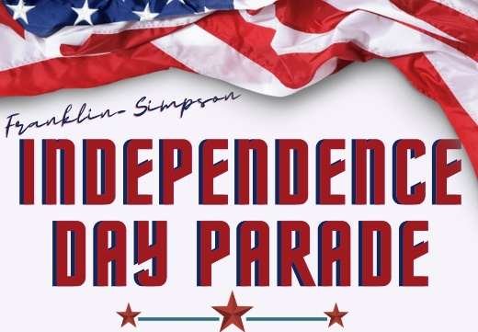

2023 Independence Day Parade Entry Form
Tuesday, July 4, 2023
10:00 am

Cancelled if Raining

Please complete and return preregistration entry forms no later than June 30th. Entry forms
can be mailed to the address below or had delivered to
Lisa Deavers at Franklin-Simpson Parks and Recreation Office located in the Ag Building
at Jim Roberts Community Park at 298 Community Park Circle

Forms can be mailed to: Frankin-Simpson Parks and Recreation
ATTN: Parade
P.O. Box 109
Franklin, KY 42135

For questions, contact Lisa Deavers at 270-586-8999 or lisa@fsparksandrec.org

```````````````````````````````````````````````````````````````````````````````````````
***NO ENTRY FEE TO PARTICIPATE***
PARADE GUIDELINES MUST BE FOLLOWED

Entry Contact Information

Name/Group Name/Business Name:_________________________________________

Responsible Person: _____________________________________________________

Address: _______________________________________________________________

______________________________________________________________________

Phone Number: _________________________________________________________

E-Mail: ________________________________________________________________

Number to Text: _________________________________________________________
Parade Entry

Check the appropriate option that best describes how you will be participating in the parade:

_____ Float

Organization or Business: _________________________________________________

_____ Vehicle

Type: _________________________________________________________________

_____ Animal

Type: _________________________________________________________________

_____ Other

Type: _________________________________________________________________

Parade Guidelines

General Guidelines
- All entries must complete an application and liability waiver to participate in the parade.
- The individual who completes this parade application is responsible for their group’s participants.
- Transportation to and from the staging and pick up location is the responsibility of the participants.
- All entries MUST be decorated and MUST be partriotic.
- Parade line-up will begin at 8:00 am. All entries must be in line no later than 9:30 am.
- The day of the parade, all drivers MUST check-in and a liability waiver must be on file.
- Drivers MUST stay with their floats at all times. Leaving a float/vehicle unattended is strictly prohibited.
- Parade float and entries shall have a sign or banner that identifies the group or organization.
- NO smoking, vaping or alcohol will be allowed on any parade entry at any time.
- All participants/entries must remain moving in a forward motion with the parade during the whole event.
- It is recommended that parade participants be dressed in patriotic attire.
- Candy may be passed out by parade participants.
- If rain or storms prevent the parade from occurring on July 4th, it will not be rescheduled.
- Restroom facilities will be available at the staging area.

Vehicle Entry Guidelines
- Vehicles should be decorated with a patriotic theme.
- At all times, vehicles should be driven in a safe manner and adhere to Kentucky State Law.
- ATV’s will be allowed and must wear a helmet. ATV’s should be decorated.

Animal Entry Guidelines
- One group representative needs to check in at staging area location for proper line-up order.
- All animal riders must ride in a safe manner and be in control of their animal at all times.
- Animal riders are encouraged to decorate their animals for the parade and wear patriotic attire.
- Waste collection is required for all animals participating in the parade. Theis may be by means of a bag attached to the animal or by a person walking the route to scoop waste.
- All animals not being ridden, must be on a leash, unless otherwise approved by the committee.

Float Guidelines
- Float height should not exceed 14’ to clear lines.

Participants riding or walking as part of an entry will be required to sign a liability waiver on-site prior to the start of the parade.

I, and my organization, would like to participate in the 2023 Independence Day Parade, and I , individually and as an authorized representative of my organization, have read and understand all of the rules and regulations for said parade, and agree to abide by same, and further waive, discharge and release the Independence Day Parade Committee, Simpson County Fiscal Court, the City of Franklin, Simpson County Tourism and/or Franklin-Simpson Parks and Recreation from all liability to myself and/or all participants from my organization. I understand and agree that the Independence Day Parade Committee reserves the right to reject this application.

Authorized Signature Date

